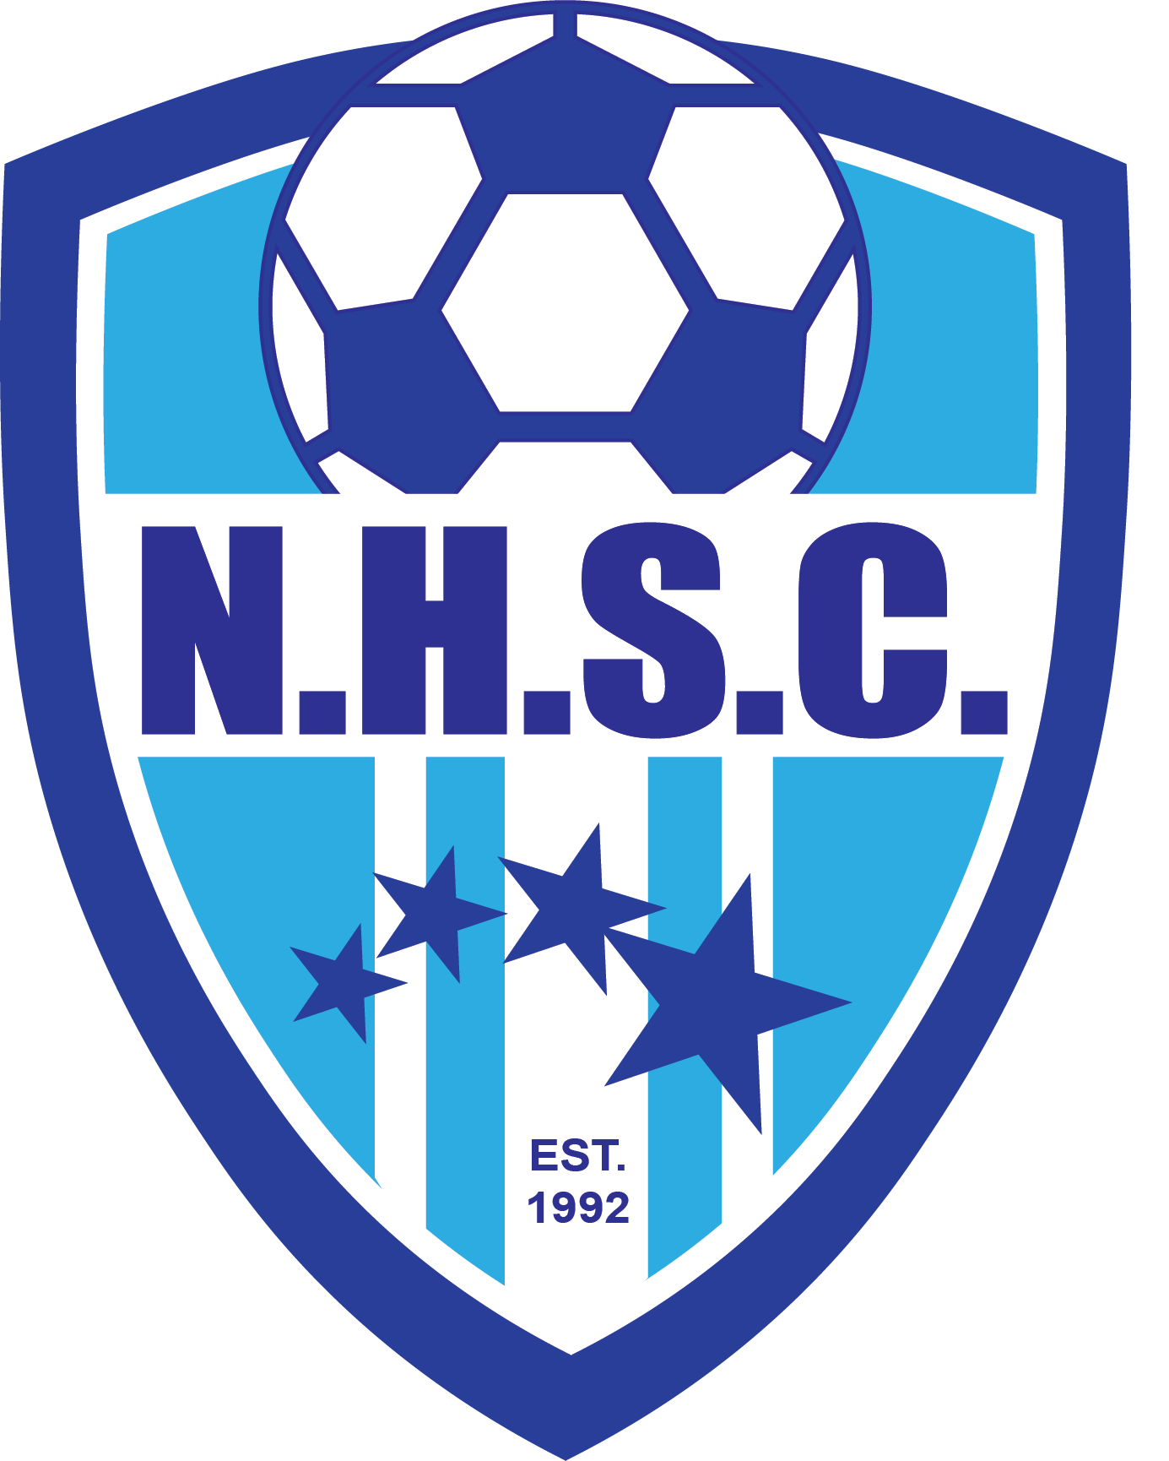

NHSC Nomination Form for Annual Members Meeting
September 30, 2025

President ______________________________________________________
Vice President __________________________________________________
Treasurer ______________________________________________________
Secretary ______________________________________________________
Director of Sponsors _____________________________________________
Director of Player Development ____________________________________
Director of Boys _________________________________________________
Director of Girls _________________________________________________
Director of Grassroots ____________________________________________
Director of Equipment ____________________________________________
Director of Media Relations ________________________________________

Signature __________________________________________________________
Date:______________________________________________________________

